

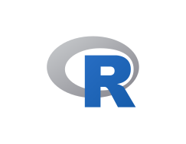

Explore

**R** is a programming language for **statistical computing and data visualization**. It is widely used in fields such as data mining, bioinformatics, and data analysis. The core R language is augmented by a large number of extension packages, containing reusable code, documentation, and sample data. [R software is open-source and free, licensed under the GNU General Public License1](https://en.wikipedia.org/wiki/R_%28programming_language%29)[2](https://www.geeksforgeeks.org/r-programming-language-introduction/)[3](https://www.r-project.org/about.html).

Here are **five free resources** where you can learn R:

1. [**Codecademy’s Learn R Course**](https://www.codecademy.com/learn/learn-r): This course covers R basics, data frames, data cleaning, and data visualization. It’s a great starting point for beginners.
2. [**DataCamp’s Introduction to R**](https://www.datacamp.com/courses/free-introduction-to-r): Master the basics of data analysis in R, including vectors, lists, and data frames. Real data sets are used for practice.
3. [**Learn-R.org**](https://learn-r.org/): An interactive R tutorial with examples and exercises. Whether you’re new to programming or an experienced coder, this resource will help you learn R efficiently.
4. **R Programming at Wikibooks**: A comprehensive guide with detailed explanations and examples. It covers various aspects of R programming.
5. **R Project’s Official Website**: The official site provides documentation, tutorials, and links to additional resources. It’s a valuable hub for R users.

Happy learning! 📊📈